3. Intra-process communication
Sub-topics:
- The challenges performing intra-process communication
- Message queue
  - The premises for designing it
  - Various design solution – Which one chosen and why
  - Its design implementation
- Impact on design/implementation before and after the Message Queue

The challenges performing intra-process communication
- Entering critical sections may happened multiple time in one thread process iteration
- Synchronization of multiple resources between threads
- Timing can be a design challenge, and tends to lead to issues
- Improper use of synchronization methods can lead to:
  - Dead locks
  - Resource starvation caused by timing issues
    - Performance issues

Message queue
The premises for designing it:
- Threads using the MQ should no have to use locking
- Other threads must be able to pass control and/or data to a specific thread
  - Multiple threads must be able to do this at the same time
- Sending or receiving from a full/empty queue must result in blocking and waiting
- No polling or sleeping
  - Polling causes valuable CPU resources to be used with no real purpose
  - Sleeping threads will not wake up exactly when it is needed to
Design solutions:
- Parsing around void pointers or byte arrays
  - Can contain anything but..
  - has no type safety
- Template based solution
  - Type safe
  - Can be a good solution if the MQ is designed around it
- Inheritance
  - Messages to be parsed around are derived classes/structs
  - Simple and extensible with sub-classing
  - Type safe
  - Causes a bit of overhead
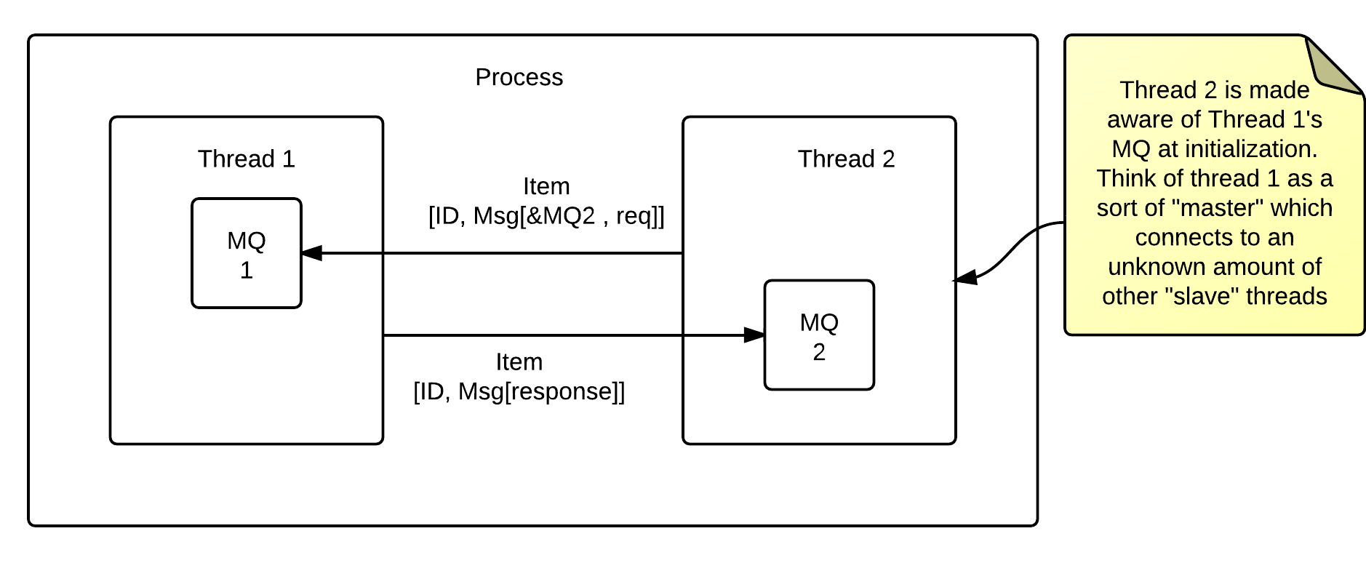
Implementation:
- Based on the inheritance model
- An “item” struct containing a Message* and an identifier is used
  - The identifier is used to identify which Message derived class is being sent
  - The message derivative contains the data we want to pass around
  - The message derivative can contain the address of the senders own MQ
    - This way the receive know where to send its response
- This implementation requires threads to be “aware” of each other

Impact on design/implementation before and after the Message Queue
Negative:
- Performance might not be great
- Threads waiting for messages are not guaranteed an answer
  - A timeout can be used
Positive:
- Easy to use correctly
- Amount of critical sections is reduced
- Not blocked on a conditional and a mutex while waiting
  - Note: Indirectly blocked in the implementation of the MQ

